**Subdue the Earth? . . . Or the Universe?**

**S&C DOC 005**

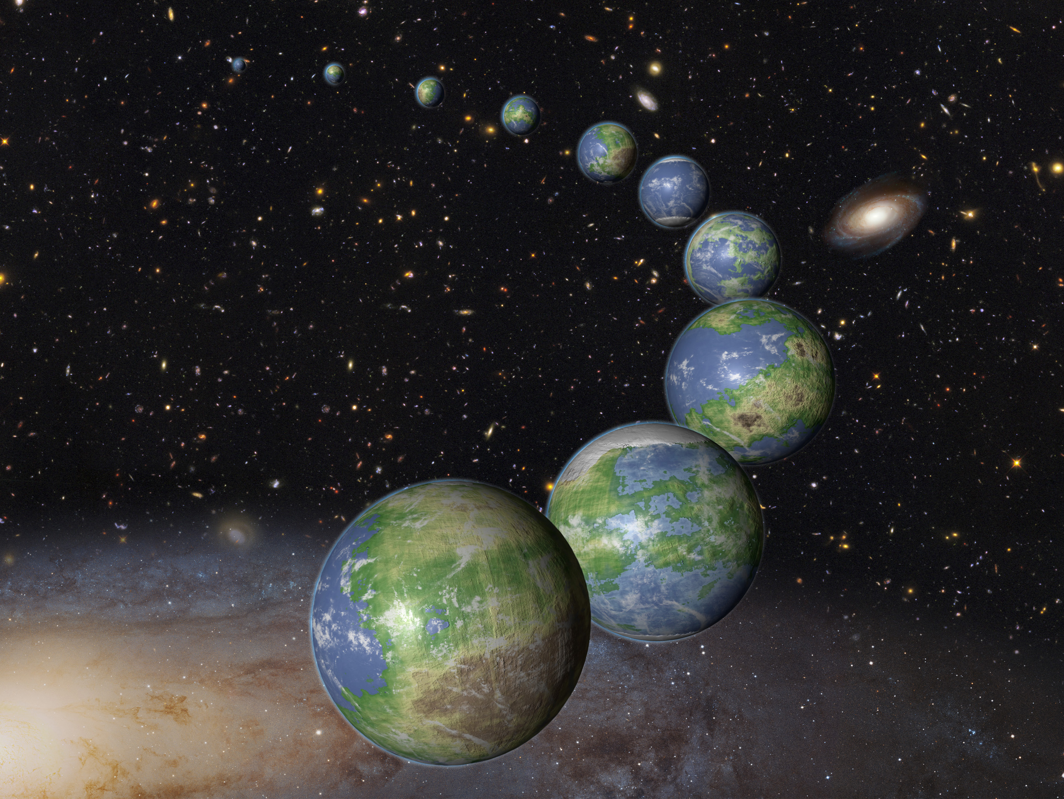

And God blessed them, and God said unto them, Be fruitful, and multiply, and replenish the earth, and subdue it: and have dominion over the fish of the sea, and over the fowl of the air, and over every living thing that moveth upon the earth. Genesis 1:28, KJV.

The earth is the domain of humans,

For thou hast made him a little lower than the angels, and hast crowned him with glory and honour. Thou madest him to have dominion over the works of thy hands; thou hast put all things under his feet: Psalm 8:5-6, KJV.

The warfare between Satan and God moved to earth, for Satan lost quite readily in that earlier war in the heavens. Satan must war by proxy now. Being envious of God’s position as ruler of all, Satan thinks that if he can imitate God, he can win. Not being a creature of earth, Satan must recruit or deceive followers, which is what he did with Adam and Eve. “The serpent beguiled me, and I did eat.” Genesis 3:13b, KJV.

A note on interpreting the word “earth:” One of the prejudices revealed in those translating the book of Revelation is the way they translate the Greek word “ge.” The translators always translate it as “earth” or “the earth.” But it can also be translated, “the land,” as in “the land of Israel“ or “the land of Egypt” or just “the land,” which normally in scripture refers to the geographic confines of Canaan. The translators’ choice of “the earth” broadens the meaning of the term to cover the entire globe. “Ge” has several meanings.

arable land;

the ground, the earth as a standing place;

the main land as opposed to the sea or water;

the earth as a whole:

the earth as opposed to the heavens;

the inhabited earth, the abode of men and animals;

a country, land enclosed within fixed boundaries, a tract of land, territory, region.

Blue Letter Bible website, Strong’s Exhaustive Concordance, the Greek word “ge,” https://www.blueletterbible.org/lang/lexicon/lexicon.cfm?Strongs=G1093&t=KJV, accessed on October 17, 2017. Therefore, could we be missing something if what we read in our English bibles as “earth” really refers to something different from what we’ve become accustomed.

However, the purpose of this paper is not to examine the proper use of “ge” in Revelation. It’s to examine the Genesis passage quoted above. Have we short-sightedly limited the meaning of earth in Genesis 1:28?

The first time that I remember questioning the meaning of the word “earth” in Genesis was while watching the movie “Interstellar.” See MOV DOC 002. The Hebrew word for the word “earth” in Genesis 1:28 is “ 'erets.” Its meaning is also multiple.

land, earth

earth

whole earth (as opposed to a part)

earth (as opposed to heaven)

earth (inhabitants)

land

country, territory

district, region

tribal territory

piece of ground

land of Canaan, Israel

inhabitants of land

Sheol, land without return, (under) world

city (-state)

ground, surface of the earth

ground

soil

(in phrases)

people of the land

space or distance of country (in measurements of distance)

level or plain country

land of the living

end(s) of the earth

(almost wholly late in usage)

lands, countries

often in contrast to Canaan

If the word “ ‘erets” can mean land, soil, ground, then are we limiting the meaning God intended for it if we say the Dominion Mandate applies only to planet earth? What about all the other ground, soil, and land that exists in the entire universe?

The believer in evolution, that is, macroevolution, which is the idea that somehow life came into being spontaneously, without a prime mover or intelligent, supernatural personal being, has based his worldview upon chance chemical reactions, which defy the laws of science. Once that believer accepts the idea that things happened by chance to “create” the world and the abundance of life that we encounter on earth, then what are the chances that such could have occurred elsewhere in the universe? Well, the chances are pretty good.

But if one looks at life and the universe through the lens of exact science, the universe and life are simply impossible. Therefore, that intelligent, supernatural being had to create it all. And to discover if there is life anywhere else in the universe, we would have to either discover it or ask Him. He has not revealed that to us in the scripture, which is all we need to be “perfect, throughly furnished unto all good works.” II Timothy 3:16-7, KJV.

Therefore, the evolutionist looks backwards to recreate the universe in a godless fashion. And he uses that theory to speculate about other life in the universe. But this is not what I’m doing. I’m taking the scripture and examining the word “earth,” which God inspired Moses to use in Genesis, because I don’t want to illegitimately limit our responsibility under the Dominion Covenant. Being careful about the word “earth” in Genesis 1:28 is particularly important when we live at the very infancy of space exploration by mankind.

Is it possible that God intended for man to colonize the rest of the universe? It would certainly help resolve concerns, reasonable and unreasonable, about overpopulating the earth. A reasonable concern about overpopulation would arise in someone who has a long-term perspective of life on the Earth, that is, on planet Earth. It’s the thought that we have a long time to go until the end of history, when Christ returns to put down that final enemy, death. “For he must reign, till he hath put all enemies under his feet. The last enemy that shall be destroyed is death.” I Corinthians 15:25-6.

If we are supposed to take dominion over all the earth in the universe, then we’ve got a long way to go. Such a task would also explain what human beings in glorified physical bodies will be doing after Jesus Christ returns at the end of history. But that does not mean we wait until He returns. It depends on that little word “earth” in Genesis 1:28.

Such a project would require lots of time and technology we don’t have now. Just the time to get to other planets in our solar system is immense. Mars is our closest neighbor with the least hostile atmosphere, temperature, climate, and other relevant planetary conditions.

How long is the trip to Mars?

However, typical Mars mission plans have round-trip flight times of 400 to 450 days. A fast Mars mission of 245 days round trip could be possible with on-orbit staging. Using Hohmann transfer orbits is a common plan.

Bing search, “trip to Mars time,” https://www.bing.com/search?q=trip%20to%20mars%20time&qs=n&form=QBRE&sp=-1&pq=trip%20to%20mars%20time&sc=6-17&sk=&cvid=246BD0373E68494BA0308FFEB9F6A775, accessed on October 18, 2017. Such missions would need to be long enough to get work done. Perhaps small replicas of Earth would have to be built first. From those habitats, people would work the planet to make it fit for arable land, mining, living, and other human activities.

Bio domes are going to be the stop gap measure of supporting colonies in less habitable environments until a method of terraforming is perfected. Some aspects of terraforming are theoretical while some practiced. The more we learn about our planet and the dynamics of its atmosphere and ecosystem, the better we can apply that knowledge to terraforming and even perfecting bio domes.

Shuttling food stuffs to Mars for example is cost prohibitive for a colony.

Quora website, “Can we make Earth-like habitats on Mars using big biodomes?,” https://www.quora.com/Can-we-make-Earth-like-habitats-on-Mars-using-big-biodomes , accessed on October 18, 2017.

As the above online article shows, we already have a word for the process of making another planet more earth-like – “terraforming.” According to Wikipedia, “terraforming” is:

Terraforming (literally, "Earth-shaping") of a planet, moon, or other body is the hypothetical process of deliberately modifying its atmosphere, temperature, surface topography or ecology to be similar to the environment of Earth to make it habitable by Earth-like life.

Wikipedia website, “Terraforming,” https://en.wikipedia.org/wiki/Terraforming, accessed October 18, 2017.

So, are Christians teaching and discussing this matter and how it plays out according to scripture? I think that most would think it interesting but a waste of time. They either haven’t thought through the matter, or they don’t think we’re going to be here on Earth long enough to accomplish the task. Then there are the silly questions, like “If we humans are to populate the universe, how does Jesus come back to Earth at His second coming and gather all believers to Him in the heavens” This gets the cart before the horse. First, let the scripture determine your understanding about your duty, then worry about the practicalities of application afterwards. Just as we believe that the Creator God can solve the practical problem of God collecting the scattered molecules of our old bodies to create new, resurrected bodies, He can resurrect and translate the dead and living bodies of people in outer space. (He has already solved the problem, seeing it was never a problem for Him.) Second, that statement also evidences a mind still set on the end of history being near; it does not evidence a person who understands the importance of redeemed man fulfilling the Dominion Mandate, something that will take quite a while to do.

There’s already a lack of teaching on the Dominion Mandate in the first place. More preaching on this command of scripture would result in greater respect for the regular occupations of life – the forester, the construction person, the oil executive, the oil-rig worker, and on and on. These workers do not receive enough encouragement that what they’re doing is a part of God’s plan for the earth.

This year is the 500th anniversary of Martin Luther’s posting of the 95 Theses on the Wittenberg Church door. That act is the emblematic start to the Protestant Reformation. One of the key precepts of the Reformation was the priesthood of all believers. However, this doctrine is normally raised in the context of bible interpretation. That illustrates a truncated understanding of the concept.

A shoemaker, a smith, a farmer, each has his manual occupation and work; and yet, at the same time, all are eligible to act as priests.... Every one of them in his occupation or handicraft ought to be useful to his fellows... (Woolf, Reformation Writings of Martin Luther, I.116).

According to Luther, all believers have equally received the treasures which God has given, from the shoemaker to the farmer to the smith. No vocation stands over and above the rest. No vocation is more "sacred" than any other. No vocation is better than another. God has called all believers, without exception, to be His royal priests -- from the dockworker to the doctor, from the messenger to the manger, from the educator to the executive. No legitimate vocation is too lowly to be the vehicle through which God will do His work (Eastwood, *The Priesthood of All Believers,* p. 12).

Center for Reformed Theology and Apologetics website, *Trading Places: The Priesthood of All Believers*, David Hagopian, http://www.reformed.org/webfiles/antithesis/v1n3/ant_v1n3_record.html, accessed on October 20, 2017.

The position as priest contains within it a calling by God to an occupation. Thus, the calling is not just for preachers. Even reformed believers fall into the trap of thinking that some are “specially called” to “the ministry,” but all believers are called to the ministry, whether as a construction worker, a farmer, a businessman, a lawyer, or a civil official.

Or astronaut or flight technician at NASA Space Center or mining engineer on Mars. If dirt or soil or earth is what we are take dominion over, how can we limit it to the dirt our planet Earth only? The only requirement is that we be faithful to God in that calling. We do that by obeying His word.